Steps to Launch EC2 Instance in AWS
- Step 1: Log in to AWS Management Console and Open EC2
- Step 2: Click on Launch Instance
- Step 3: Choose an Amazon Machine Image (AMI)
- Step 4: Choose an Instance Type
- Step 5: Configure Instance Details
- Step 6: Add Storage
- Step 7: Add Tags
- Step 8: Configure the Security Group
- Step 9: Review and Launch
- Step 10: Create/Select a Key Pair

Step 1: Log in to AWS Management Console and Open EC2
Login to AWS Management Console and open the EC2 service.
You can either go to Services -> Compute -> EC2
or type EC2 in the search bar and hit enter. Once you see the EC2 option click on that.
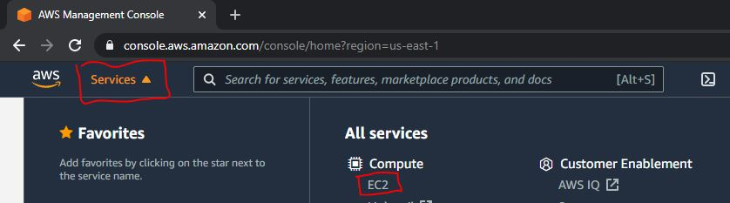
This will lead you to the EC2 dashboard like below.
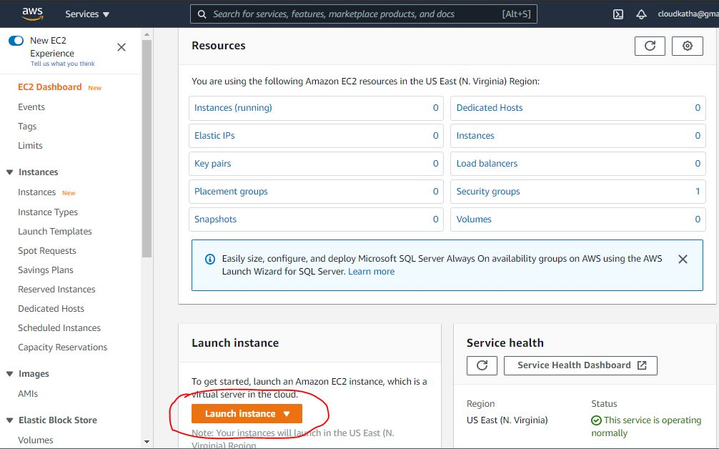

Step 2: Click on Launch Instance
Once you are in the EC2 dashboard, you can see a summary of all the EC2 resources in your selected region.
To Create EC2 Instance in AWS, Click Launch Instance
Note: Please select the correct region in which you would like to launch your instance before actually launching it
Suggested Read:
- Launch EC2 instance in an existing VPC using CloudFormation
- Attach an IAM Role to an EC2 Instance using CloudFormation

Step 3: Choose an Amazon Machine Image (AMI)
Once you click on Launch Instance, you will be presented with a 7-step configuration screen.
There are lots of configurations but we will only go through the necessary ones.
Let’s start with choosing an AMI.

What is AMI?
AMI or Amazon Machine Image is nothing but a pre-configured template which contains software configurations for your instance for example operating system or the application server etc.
Note: You must specify an AMI when you create your EC2 instance in AWS.
I am going with Linux 2. It is also eligible for a free tier. You can select as per your requirement.
If you are launching your instance for learning purposes, make sure to select an AMI which says free tier eligible like in the screenshot below.
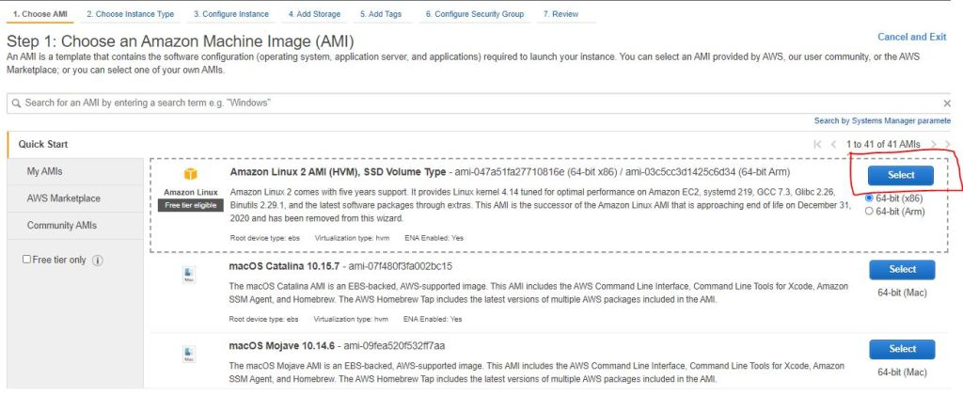

Step 4: Choose an Instance Type
After selecting AMI, you will be taken to the instance type selection screen.
Instance Type is basically the selection of hardware configurations for your instance for example CPU, memory, storage, and networking capacity.
AWS provides a wide range of instance types to fit different use cases.
I am going with T2.micro because it’s free. It provides 1vCPU and 1GB of memory which is good enough for learning purposes.
Suggested Read: How to choose right instance type for your workload.
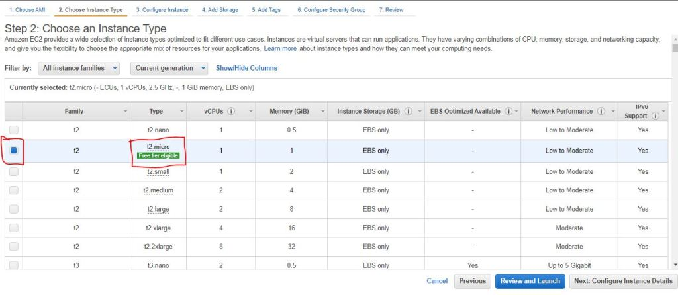
You can either review and launch with the default configuration or go ahead and configure instance details.
Let’s go to the instance details screen at least to see what it has to offer.

Step 5: Configure Instance Details
In the instance details screen, you can configure a lot of details about your instance for example-
- How many instances do you want
- VPC and subnet in which you want to launch an instance
- Assign Public Ip to an instance
- Attach an IAM role to an instance etc.
The list is really long !!!
But, don’t worry, we will only choose basic ones.
I have chosen the Number of Instances to 1 and selected the VPC and Subnet in which I wanted to launch my instance.
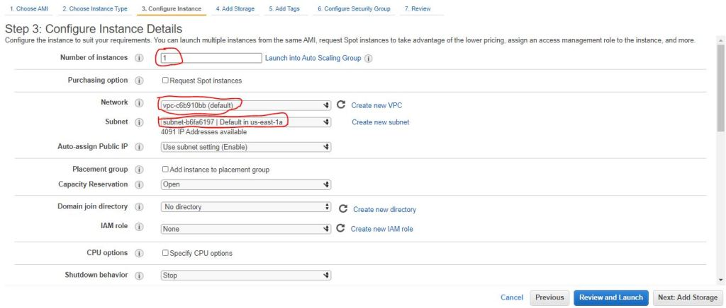
If you scroll down, you can see some other settings as well. But let’s ignore them as of now. But to be honest, most of them are self-explanatory.
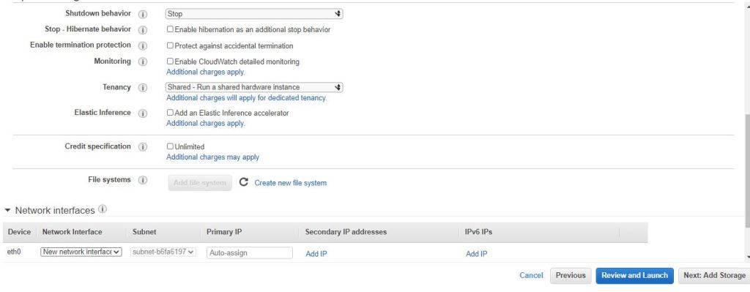
As I said, I will leave everything as default and click on add storage

Step 6: Add Storage
As the heading says, on this screen you can either modify the root volume settings or you can add New volume if required.
I am going with default only but please feel free to tweak this as per your requirement.
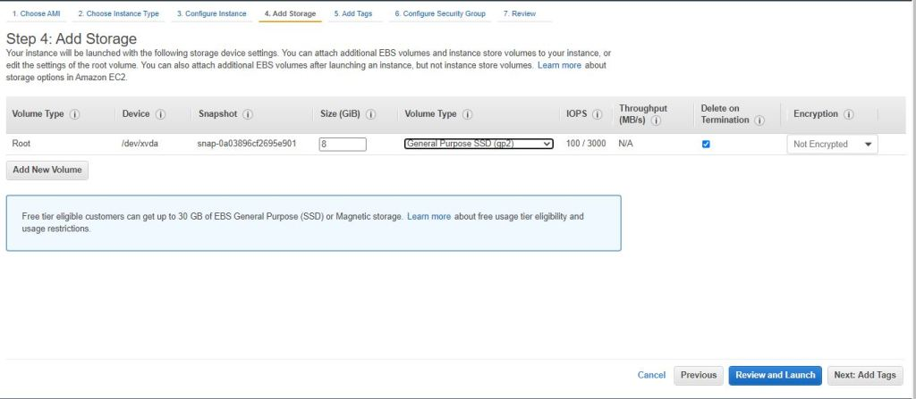

Step 7: Add Tags
Tags are optional for your instance but they are always good to have.
They are basically key-value pairs which provide additional information about the instance for example Name or Environment etc.
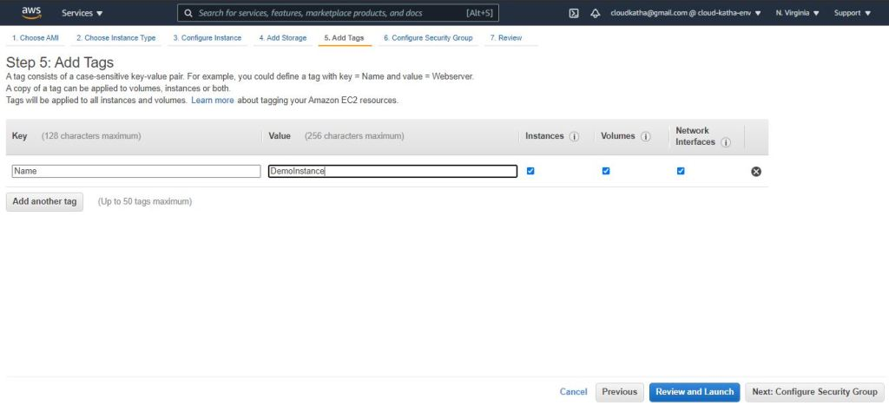
I have used one tag which is Name = DemoInstance.
As the tag applies to Instances, volumes and network interfaces, You will notice that all of them will have the name DemoInstance
Note: You can always uncheck the checkbox against any one of them if you don’t want the tag to be applied.

Step 8: Configure the Security Group
Security Group lets you control traffic to and from your EC2 instance.
It’s basically an additional firewall provided by AWS to let you block unwanted ports or open required ports.
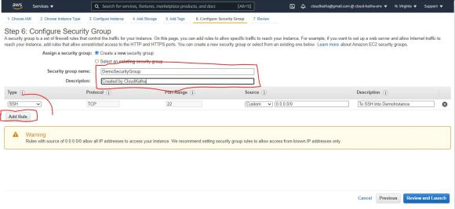
I have left the default security group config with only 22 ports open for SSH so that I can connect to my instance.
But, feel free to open 80 or 443 on your instance if you are planning to use your instance like a web server.
Note: Always open only the required ports

Step 9: Review and Launch
Review all your selected configurations. You can always go back and change anything you want either by clicking the previous button or directly by clicking on a specific step.
If everything seems to be good, you can click on Launch.
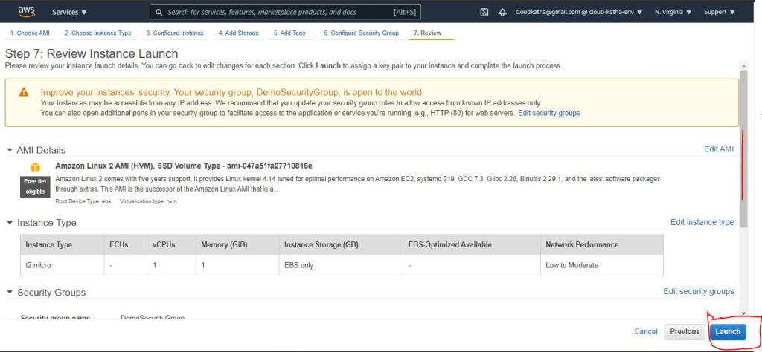

Step 10: Create/Select a Key Pair
On clicking launch, you will get a popup screen to select an existing key pair or create a new one.
You might wonder What is a key pair?
Well, A key pair consists of a private key(your store) and a public key(AWS store). Together they let you connect to your instance securely without any password.
To be more precise, You use the private key, instead of a password, to securely access your instances.
I will go ahead and create a new one.
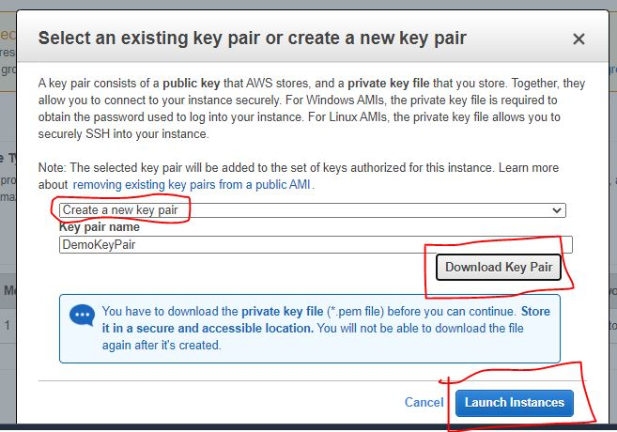
Select Create a new key pair option – > name your key pair -> Download Key Pair -> Launch Instance
Note: You can also go ahead by selecting “proceed without a key pair”. But, you will not be able to SSH into your instance ever
Download key pair and click Launch Instances
You will see the status that your instance is launching below.
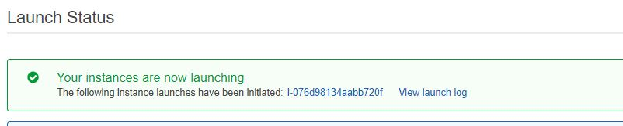
Scroll down the page and click on View Instances
You will see like below.
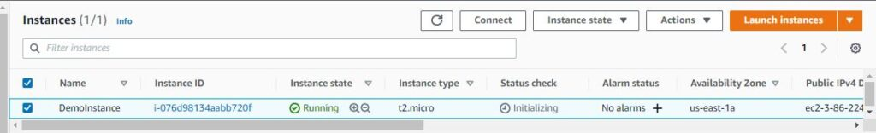
Instance state is Running. You can click on the Instance ID to see more details about your instance.
Yay, Congratulations!!!
You created your EC2 instance or virtual server in the AWS cloud 🙂

Steps to Install Apache Web Server on Amazon Linux 2
- Launch an EC2 Instance(Linux 2)
- Connect to your Linux 2 Instance
- Install Apache Web Server
- Configure the Security Group of instance to allow ports 80 and 443
- Verify the Installation
- Customize the web page
- View Customized Web page
Let’s get started …

Step 1: Launch an EC2 Instance(Linux 2)
Before we install the Apache web server or httpd on the EC2 instance, we will need an EC2 instance up and running. You can refer to my previous tutorial to launch a Linux 2 instance in AWS.
Link to tutorial: How to Launch EC2 Instance Step by Step in AWS

Step 2: Connect to your Linux 2 instance
Once your instance is up and running, you need to connect to your instance. I will be using the EC2 instance connect feature for this as it allows SSH into instances from the browser itself.
However, if you want to usual SSH, feel free to use the below command from your terminal.
ssh -i /path/my-key-pair.pem ec2-user@instance-public-ip

To SSH from the browser using Instance Connect, follow the below steps.
- Select your instance and click connect as highlighted below
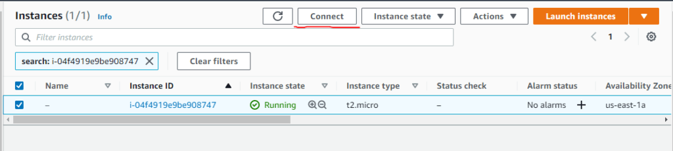
2. Once, you click Connect, you will see a screen with the default username for a Linux 2 instance
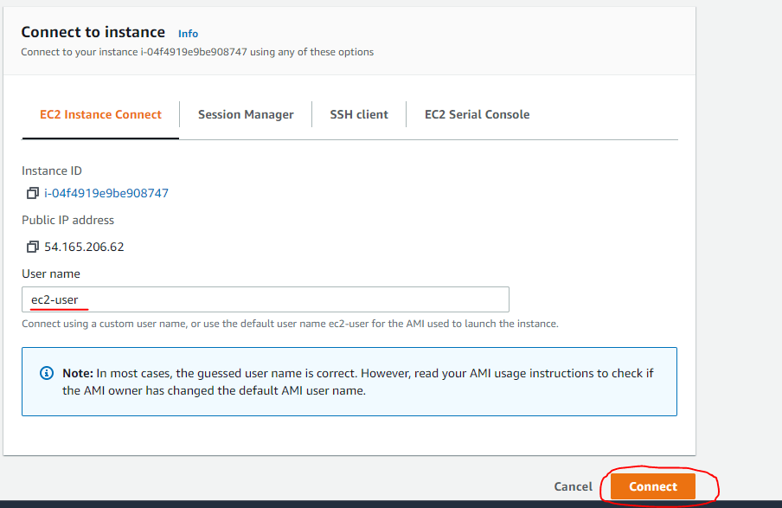
Verify that ec2-user is showing in the username field and click Connect.
A new browser window will open and you will be connected to your instance like below.
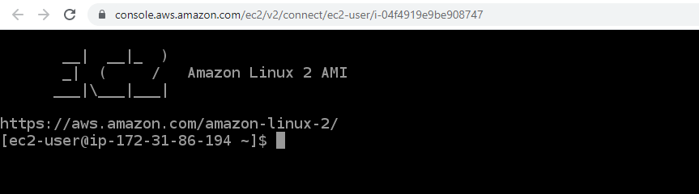
Amazing !!!
Now you are ready to run commands on your EC2 instance. Let’s move to the installation part in the next step.

Step 3: Install Apache Web Server on Amazon Linux 2
Now, we need to run the below set of commands one by one, to install the Apache web server on our instance. Please note that we will use sudo(root privilege ) to run all these commands. The reason is that whenever you try to install, remove or change any software, you must have root privilege to do such tasks.
sudo yum update -y
sudo yum install -y httpd.x86_64
sudo systemctl start httpd.service
sudo systemctl enable httpd.service

Explanation of commands
1. Update the latest package available on the system
It’s a best practice to update all the packages to the latest ones before installing anything new.
sudo yum update -y
2. Install Apache Web Server
sudo yum install -y httpd.x86_64
3. Start Apache Server
The above command will install the Apache web server but it will not start it. You need to explicitly start the server using the below command
sudo systemctl start httpd.service
4. Configure Apache to run on system boot
It is your web server and you always would like it to auto-start on system boot. Isn’t it?
You can do so by the below command
sudo systemctl enable httpd.service
At this moment, your Apache web server is already installed and started in your Linux 2 instance. But, you can’t access it right now. if you try to hit the public IP you will get an error like This site can’t be reached.
Why?
Because our EC2 instance doesn’t allow web traffic yet.
On the security group, only SSH is allowed as of now.
Let’s change that.

Step 4: Change the Security Group of the instance to allow ports 80 and 443
Let’s allow web traffic on ports 80 and 443(Internet traffic for HTTP and HTTPS).
Click on your instance ID to see the instance details. Scroll down and click on the Security Tab and you should see the security group like below.
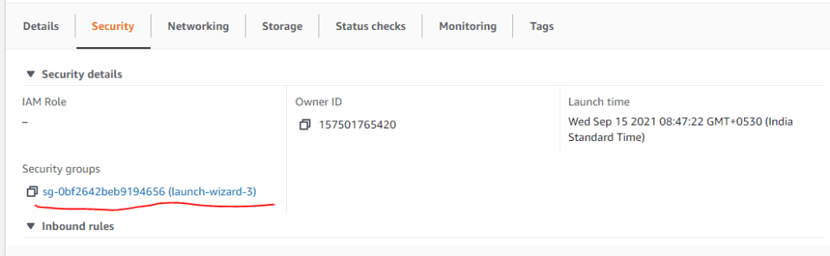
Click on the Security Group ID link -> Click on Edit Inbound Rule
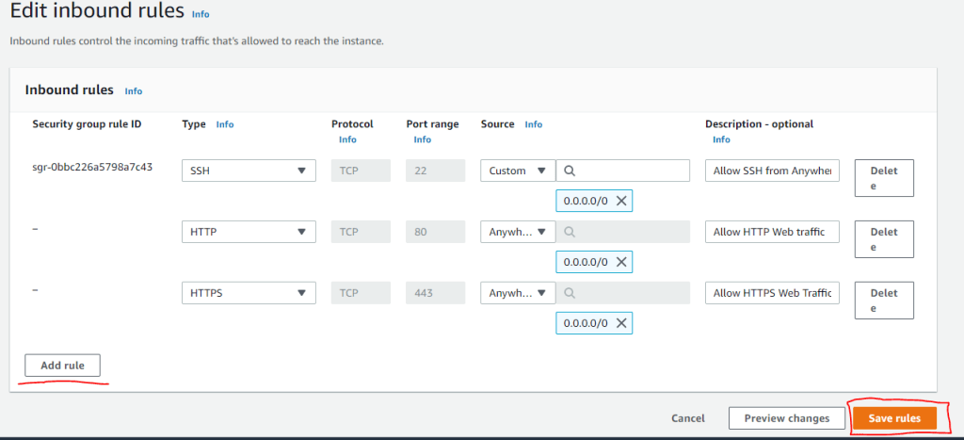
Use the Add rule button to add more rules one by one.
Specify rules for HTTP and HTTPS Web traffic from anywhere like above.

Step 5: Verify the Installation
We have installed and started the Apache web server.
Our instance allows web traffic now, it’s time to grab the public IP or public DNS of the instance.
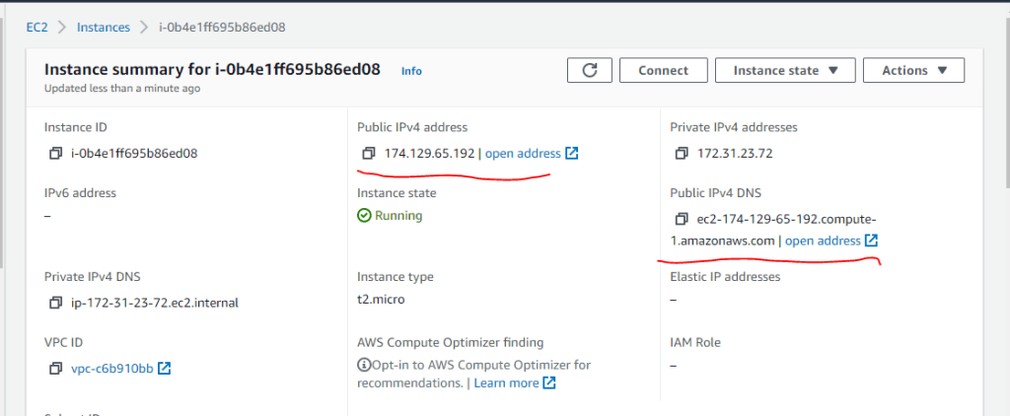
Click on the open address and you should be able to see the Apache default page below.
Note: You can see changes in IP on the above and below screens. The reason is, that I stopped and started my instance so the public IP changed. For you, both of these should remain the same.
Feel free to ask me in a comment if you have questions.
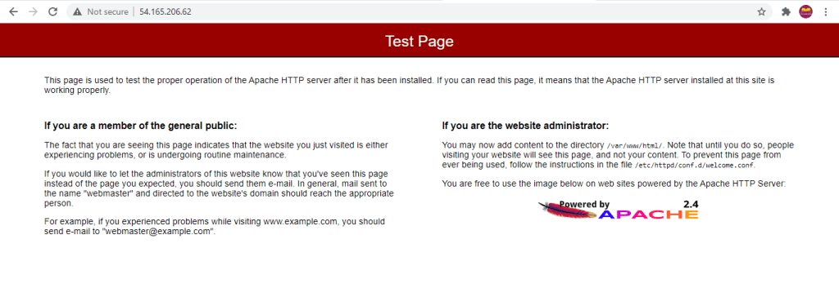

Step 6: Customize the web page
We have seen the default Apache page served by Apache. Let’s modify that.
We will create our own index.html in the Document Root folder which is /var/www/html in our case.
DocumentRoot: Document Root is the directory from which Apache looks for and serves web files on your request. So we will create an index.html in /var/www/html folder
You can use various commands to create and put content into index.html inside the folder. You can check this tutorial
For example- one of the simplest options is to use:
sudo echo “Hello World from $(hostname -f)” > /var/www/html/index.html
But ‘>’ creates a problem and the the above command ends up running as ec2-user instead of root resulting in permission denied like below.
-bash: /var/www/html/index.html: Permission denied
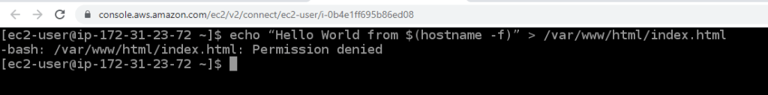
It will work if you switch your user as root using sudo su or sudo sh but I wanted to avoid that.
You might ask me, why?
Well, it is advisable to stick to sudo when performing tasks that require root privileges. By doing so, the current user is only granted privileges for the specified command. On the other hand, su switches to the root user completely and every command runs as root which is not secured.

What worked for me?
I used the sudo nano command to create the file and put content into it.
sudo nano /var/www/html/index.html
Once, the file opens up, paste the below content into the file
<!DOCTYPE html>
<html>
<body>
<h1>Hello World !!</h1>
<p>Welcome to CloudKatha</p>
</body>
</html>
Save and close the file.

Step 7: View the customized web page
This time when you enter public IP or DNS into the browser, you will see your customized page like below.
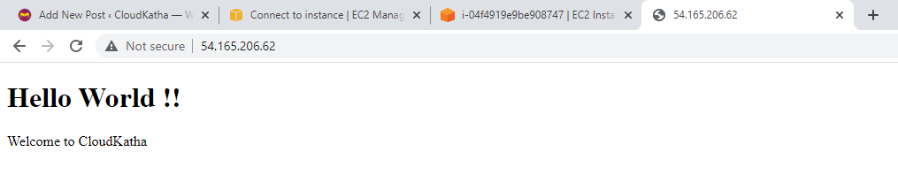
Congratulation !!!

